CURRICULAM VITAE

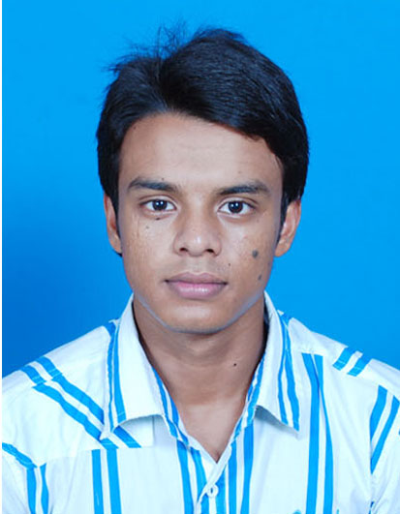
Bivash Das
Bachelor in Business Administration [BBA (H)]
Address: - B-7/235 Kalyani, Nadia
Mobile No: - 9748053351
E-mail:- bivashdas19@gmail.com

Objectives

To be potential resource to the organisation where I can utilize all my skill & knowledge which would help the organisation to grow & further enhance my growth profile. It would be my never-ending dedication to maintain the spectrum integrity, honesty & character.

Educational Qualification

QUALIFICATION | BOARD/UNIVERSITY | YEAR OF PASSING | MARKS (%) / CGPA
Secondary Examination | W.B.B.S.E | 2009 | 54.8 %
Higher Secondary Examination | W.B.C.H.S.E | 2011 | 48.8 %
Bachelor of Degree | West Bengal University of Technology | 2014 | 5.88
Post Graduation | _ | _ | _

Technical Skill

- MS Windows XP / Vista / 7
- Microsoft Word, Microsoft Power Point, Microsoft Excel etc.
- Internet Browsing
- Assembling of PC

Strengths / Special Skill

- Good Oriented, Positive & Supportive
- Positive Attitude
- Friendly behave among others
- Good communication & organisation skill
- Determine to learn with practical knowledge

Seminar Report

- Presented seminar on Tata Social Entrepreneurships at IIM Calcutta.

Interests

Bike riding, Car driving, Computer game, Playing football, Listening music, Getting information about cars etc.

Languages Known

English, Bengali & Hindi.

Personal Details

Father’s Name Bimal Das

Date of Birth 28/01/1993

Marital Status Single

Permanent Address B-7/235 Kalyani, Nadia (West Bengal)

I here by affirm that the above information is true to the best of my knowledge.

PLACE:Kalyani Sincerely yours

(Bivash Das)

